 *Final mark awarded*

FACULTY OF COMPUTING, ENGINEERING and SCIENCE

Assessment Cover Sheet and Feedback Form 2017/18

|  |  |  |  |  |
| --- | --- | --- | --- | --- |
| **Module Code:**  NG4D900 | **Module Title:**  MEng Major Group Project | | **Lecturer:**  Guoping Liu | |
| **Assignment No:**  1 | **No. of pages in total including this page:** | | **Maximum Word Count:** 15000 | |
| **Assignment Title: Report Tasks:** | | | | |
| **Date Set:**  27/09/2017 | | **Submission Date:**  25/04/2018 | | **Feedback Date:**  09/05/2018 |

|  |
| --- |
| **Section A: Record of Submission** |
| **Record of Submission and Plagiarism Declaration**  I declare that this assignment is my own work and that the sources of information and material I have used (including the internet) have been fully identified and properly  acknowledged as required in the referencing guidelines provided.  **Fit to Sit Policy**  The University operates a fit to sit policy whereby you, in submitting or presenting yourself for any assessments, are declaring that you are fit to sit the assessment. You cannot subsequently claim that your performance in that assessment was affected by extenuating circumstances.  **Student Number:**  **14031329**  You are required to acknowledge that you have read the above statements by writing your student number(s) above.  (If this is a group assignment, please provide the student numbers of **ALL** group members)  **Details of Submission**   * IT IS YOUR RESPONSIBILITY TO KEEP A RECORD OF ALL WORK SUBMITTED. * Work should be submitted as detailed in your student handbook. You are responsible for checking the method of submission. * **Late Submission** – Work must be submitted by the submission date. If you fail to do this, you will be allowed a further five working days to submit the work but the work will be awarded a maximum mark of 40%. If you fail to submit work within five working days of the submission date, you will be deemed to have failed this assessment which will be given a mark of 0%. However see extenuating circumstances below.   **Extenuating Circumstances:** if there are any exceptional circumstances that may have affected your ability to undertake or submit this assignment, make sure you contact your Advice Shop and also see either<http://cesstudents.southwales.ac.uk/Ext_circs/>(Trefforest) or <http://glyntaffcampus.southwales.ac.uk/advice_shop/Extenuating_Circumstances/>(Glyntaff) |

|  |  |
| --- | --- |
| **Section B : Marking and Assessment** | |
| This assignment will be marked out of 100%  This assignment contributes to 100% of the total module marks. This assignment is bonded / non- bonded. Details : | It is estimated that you should spend approximately  20 hours on this assignment. |

|  |  |  |
| --- | --- | --- |
| **Learning Outcomes** |  | |
| **This assignment addresses the following learning outcome(s) of the module:**   1. Work effectively as part of a multi-disciplinary team in developing and implementing a solution to a complex, industrially relevant, major technical problem, communicating effectively with a team members and, if appropriate, personnel from the sponsoring industry. 2. Demonstrate a critical and conceptual understanding of all aspects of the work, and contribute to both the production of a detailed technical report, and a concise technical presentation. 3. Demonstrate a critical and conceptual understanding of all aspects of the work, and contribute to both the production of a detailed technical report, and a concise technical presentation. | | |
| **Marking Scheme** | **Marks**  **Available** | **Marks**  **Awarded** |
| **1.** See page 5 |  |  |
| **2.** |  |  |
| **3.** |  |  |
| etc. |  |  |
|  |  |  |

|  |  |
| --- | --- |
| **Assessment Criteria** | |
| **Performance Level** | **Criteria** |
| Fail (<40%) |  |
| 3rd Class / PASS (40%-49%) |  |
| Lower 2nd Class / PASS (50%-59%) |  |
| Upper 2nd Class / MERIT (60%-69%) |  |
| 1st Class / DISTINCTION (70% +) |  |

|  |  |  |  |
| --- | --- | --- | --- |
| **Section C : Marker’s Feedback** | | | |
| **Lecturer’s Comments:** | | | |
| ……………………………………………………………………………………………………………… | | | |
| ……………………………………………………………………………………………………………… | | | |
| ……………………………………………………………………………………………………………… | | | |
| ……………………………………………………………………………………………………………… | | | |
| ……………………………………………………………………………………………………………… | | | |
| ……………………………………………………………………………………………………………… | | | |
| ……………………………………………………………………………………………………………… | | | |
| ……………………………………………………………………………………………………………… | | | |
| ……………………………………………………………………………………………………………… | | | |
| ……………………………………………………………………………………………………………… | | | |
| ……………………………………………………………………………………………………………… | | | |
| ……………………………………………………………………………………………………………… | | | |
| ……………………………………………………………………………………………………………… | | | |
| **Areas to concentrate on next time:** | | | |
| Report structure | Research | Content | Team work |
| Referencing | Presentation |  |  |
| **Lecturer’s signature:** | | **Date:** | **Mark awarded:** |
| **All marks are subject to confirmation by the Assessment Boards** | | | |

|  |  |  |
| --- | --- | --- |
| **Task distribution per student** | | |
| **Student ID** | **Name** | **Section/sub-section** |
| **13013521** | **Thomas Brown** |  |
| **15021106** | **Kayin Templar** |  |
| **14031329** | **Miguel Santos** |  |

Table of contents

1. Introduction 4

1.1. Overview 4

1.2. Project goals 4

1.3. The competition 4

1.3.1. Regulations 4

1.3.2. The race track 4

1.3.3. Results from 2017/18 4

2. Features 5

3. Design 6

3.1. Mechanical 6

3.2. Electrical 7

3.2.1. Provided Designs 7

3.2.2. Sensor Bar 7

3.2.3. Power Board 9

3.3. Speed Control and Feedback 12

3.3.1. Hall Effect Sensor 13

3.3.2. Accelerometer 15

3.1. Overall Electronic Design 16

3.2. Control theory 17

3.3. Software 17

3.3.1. Program structure 17

3.3.2. Backend 17

3.3.3. Frontend 17

4. Implementation 18

4.1. Mechanical 18

4.2. Electrical 19

4.2.1. Provided Circuits 19

4.2.1. Hall Effect circuits 20

4.2.1. Peripheral Board 20

4.3. Software 21

4.3.1. Backend 21

4.3.1.1. RTOS 21

4.3.1.2. Peripheral drivers 21

4.3.1.3. Communication protocol 21

4.3.2. Frontend 21

4.3.2.1. User application – car controller 21

4.3.2.2. User interactivity – command shell and Android App 21

4.3.3. Extra features 22

4.3.3.1. MIDI Player 22

4.3.3.2. Wireless firmware deployment (bootloader) 22

4.3.3.3. Backward and forward compatibility 22

5. Testing 23

5.1. Mechanical 23

5.2. Electrical 23

5.2.1. Sensor board 23

5.3. Software 23

6. Performance 24

7. Problems and solutions 25

8. Next year proposals 26

9. Discussions 27

10. Conclusion 28

11. References 29

Appendices 1

Appendix A: 1

Appendix B: 2

Appendix C: 3

List of tables

Não foi encontrada nenhuma entrada do índice de ilustrações.

List of figures

Não foi encontrada nenhuma entrada do índice de ilustrações.

List of abbreviations

|  |  |
| --- | --- |
|  |  |
|  |  |
|  |  |
|  |  |
|  |  |
|  |  |

# Introduction

## Overview

## Project goals

## The competition

### Regulations

### The race track

### Results from 2017/18

# Features

# Design

## Mechanical

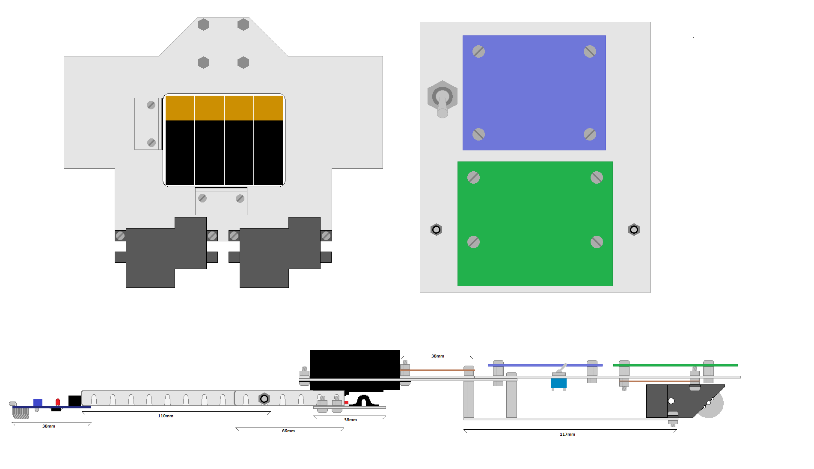In order to maximise the performance of the car, the mechanical design must be changed to give this car an edge over the default design. A problem that other cars have is a high centre of mass, which means that they have to take corners at a slower speed to avoid going out. Below is the mechanical design of this car. There are no wheels shown in this design to make it easier to see everything.

This design has the MCU board and Power board on the same level (top right), as opposed to the provided design that has them on two separate levels. This requires extending the length of the car by 30mm but allows the car to be much less tall. This top-level plate is supported by the front pillars and the gearboxes. Having the power board on the top level should help to sort out some of the cooling issues present in other cars.

The servo board is attached to two arms extending from the front axle much like the original design, but in this design the middle of the arms are secured by nylocs, which allow free movement of the arm without it becoming loose.

The top left of this diagram shows the bottom level. The battery pack (containing eight AA batteries) is supported by two small plates with Velcro strips. This should sufficiently stop it becoming loose while the car moves, while still making it easy to remove the battery pack for charging

The switch has been repositioned from the area behind the servo to make room for the peripheral Veroboard. The makes all circuits easily accessible except for the Hall Effect circuits, which have to be positioned above the gearboxes.

The gearboxes are both positioned with half of the box hanging off the back of the car. This helps two-fold; to reduce the size of the bottom level, and allowing more air to reach the motors to cool them.

## Electrical

### Provided Designs

Three boards are included in the initial project package, the IR LED sensor bar, the Power board, and the MCU board. The MCU board arrives soldered however the others must be soldered. This section will explain the function of these boards, as they must be understood in case they develop a fault, and for the designing of added peripherals.

### Sensor Bar

The first of the provided circuit designs to be discussed here is the sensor bar. The purpose of this circuit is to detect the white line on the track, and send this data to the MCU board so that the car can be controlled.

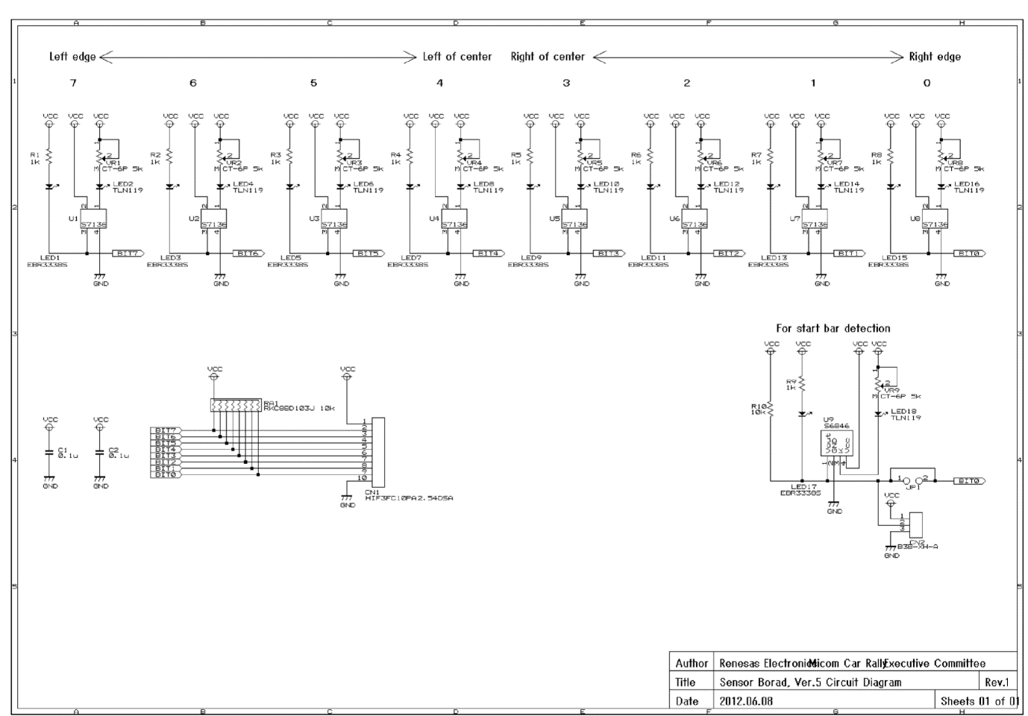

Above is the schematic for the sensor bar. As each of the LED-IR sensor sections are identical, one of them can be looked at as an example.

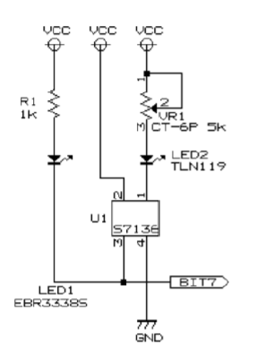The left most LED is a simple unicolour red LED in series with a 1k resistor. This LED has a forward voltage of 1.7V which means the current flow when on is $\frac{5-1.7V}{1000Ω}=3.3mA$. This LED will only be on when pin 3 of U1 goes low.

LED2 is the infrared LED which is in series with a potentiometer. As the resistance of the potentiometer is varied, the current supply, and thus intensity of light emitted varies.

Pin 1 on U1 is a cathode that sinks the current from the IR LED. Pin 2 is its power supply and Pin 4 is the ground. When U1 detects light, pin 3 goes low, turning LED1 on.

The start bar sensor works in almost the same way but shares the output Bit 0 with the right edge sensor. This means that during start up, the Bit 0 signal is used to detect the presence of the start bar, but then switches to detecting the right edge of the track.

This board is connected to the MCU via a 10 wire ribbon cord, with 8 signal wires, and 2 for Vcc and ground.

### Power Board

The power board’s function is to control and power the rear DC motors, as well as provide power to the servo and MCU. In its default state is can handle a power supply of 4.5 -5.5V, which is applied directly to the motors, the servo and the MCU board. However, with the addition of two linear regulators, it can be supplied with up to 7-15V. This increases the maximum speed of the DC motors and allows the use of more batteries in parallel, which in turn gives the car a greater on-board charge and battery life.

The schematic of this board can be divided up into sections.

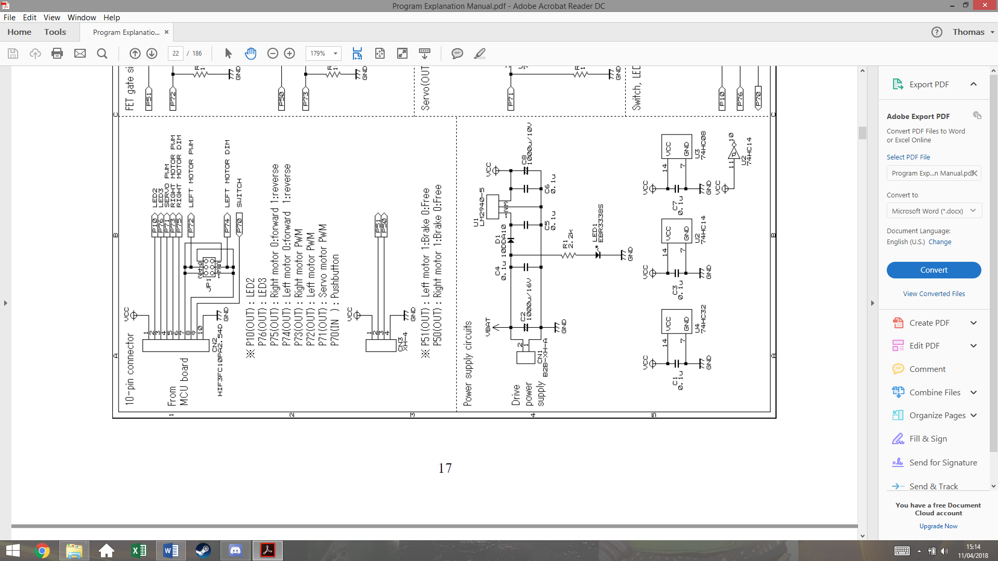This section shows the connections to the MCU board. It’s important to be aware that the Vcc is connected **from** the power board **to** the MCU board.

The ribbon cord from the MCU contains the PWM signals for both motors, and the direction signal for each motor (0 forward, 1 reverse). The only purpose for JP1 is to switch the Left Motor PWM and LEFT Motor DIM signal for other boards. This also contains the pushbutton signal that will be used to run the car.

CN3 is for optional use, and can be used for braking the motors. This is specifically useful for the 90° turns. This would not allow for any dynamic braking as it would completely stop any signal sent to the motors.

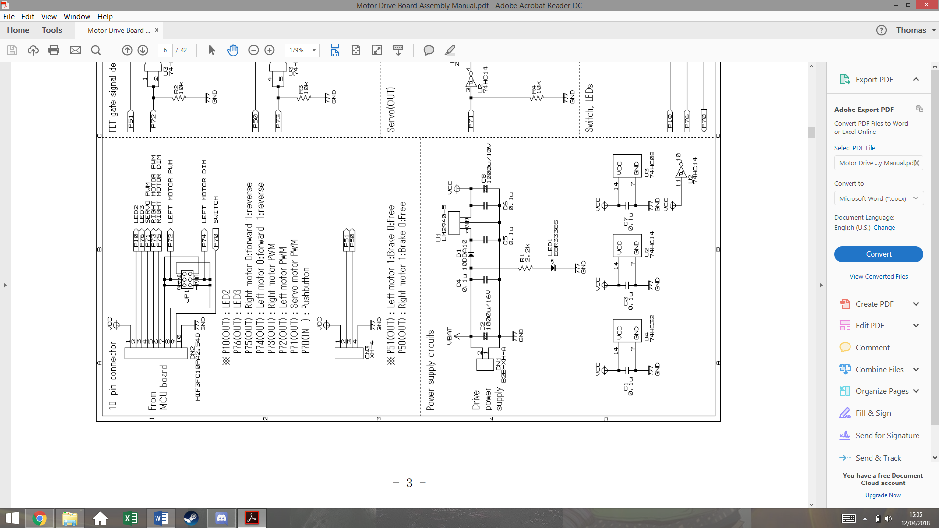

This section shows the power supply of the board. The top circuit regulates the voltage supply Vcc for the MCU board. The LM2940-5 is a 5V regulator that is not included in the initial package. C5 and C6 are also not included so these must be purchased. LED 1 is simply used to indicate that the batteries are connected and that there is power.

The bottom circuit shows the Vcc connected to the logic chips U4, U2 and U3. The capacitors C1, C3 and C7 are decoupling capacitors that remove high frequency components on the supply, often cause by the power supply switching on. This stops the chips being damaged by inrush current.

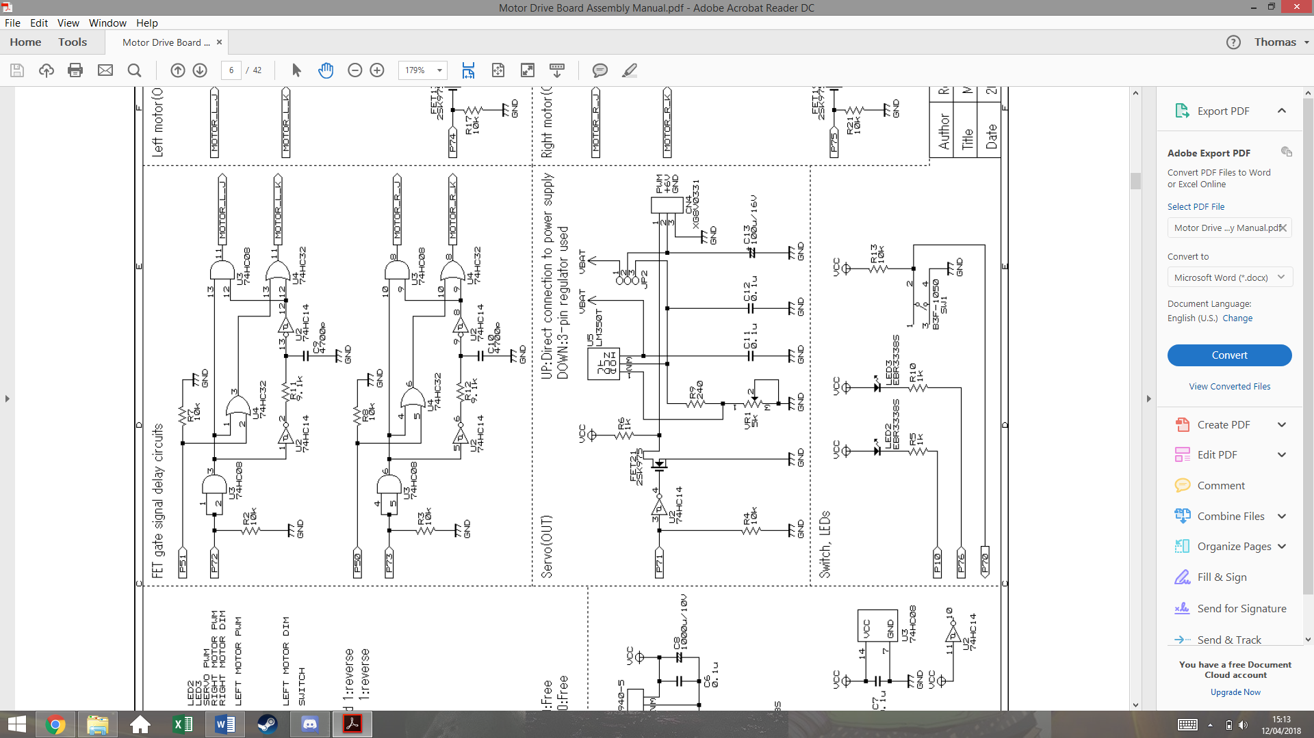This section shows the servo circuit. U5 is another linear regulator not included. This regulator is adjustable via the potentiometer VR1, which can be varied to give a 6V output. Jumper JP2 will have a short between pins 3 and 2, so connect the 6V output of U5 to the servo, instead of the battery voltage on pin 1.

U2 is an inverting Schmitt trigger that both isolated the MCU, stopping current being drawn from the port, and inverts the PWM signal.

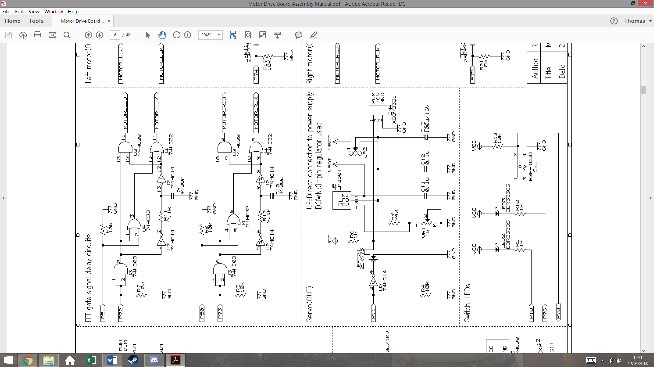

This section shows the logic circuits that control motor direction and speed. Both of these circuits are identical. The first AND gate acts as a buffer that isolates P72/73 on the MCU.

The output Motor_L_J is essentially just P72 but distorted with a delay, as it is the AND function of P72 before and after being filtered by R11 and C9. As it is filtered and then passed through a Schmitt trigger, a delay is created.

The purpose of this delay is to stop a short in the circuit that could be created later. For now, it’s easier to understand with the removal of P51.

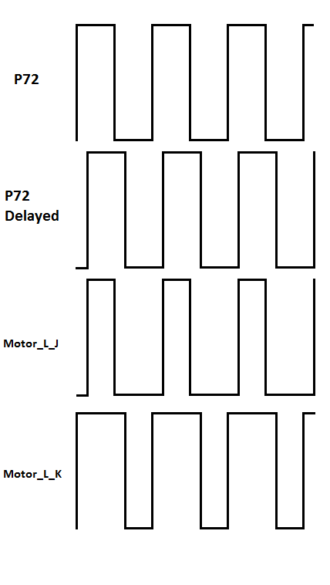This trace shows the output signals of this section of the circuit, without P51. The output Motor_L_K gets inverted by K-FETs in a later circuit. This explains how the short is prevented.

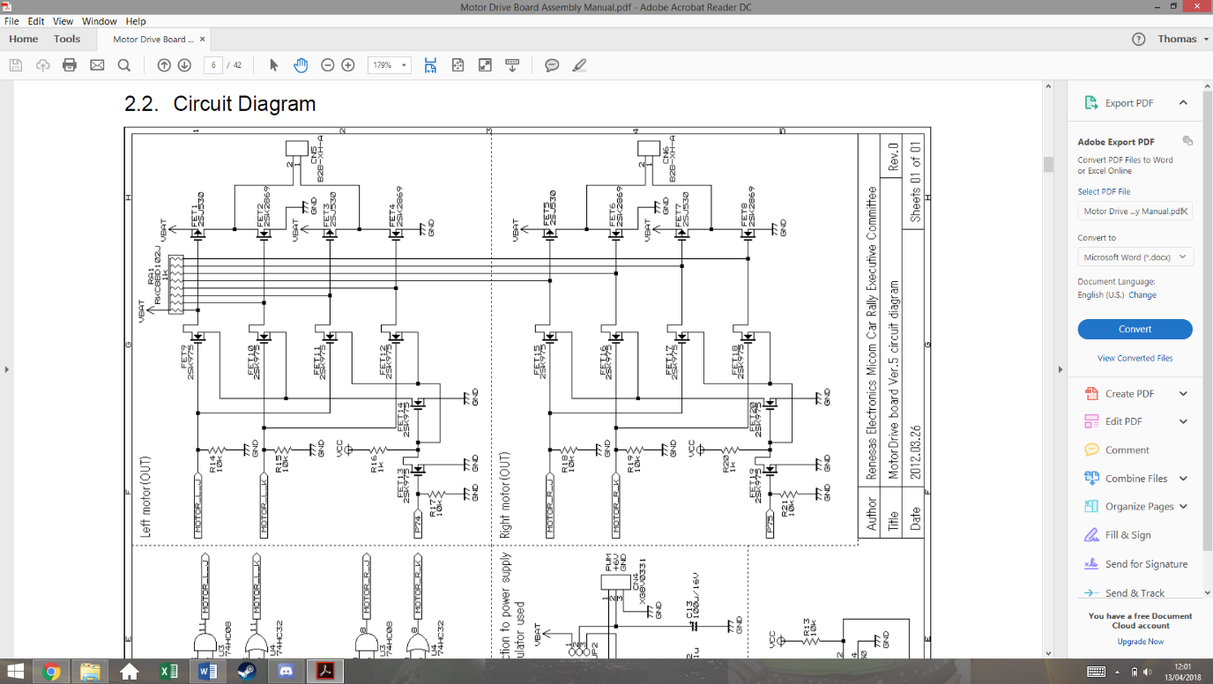

1

2

3

This final section of the power board is the transistor circuit that controls the motors. The bottom and top circuits are the same, but for the two different wheels. The circuit is made of p-channel and n-channel mosfets. It’s important to remember that n-channel allow current flow when the gate is high, whereas p-channel allow current flow when the gate is low.

FET 1, 3, 5 and 7 are p-channel mosfets, the rest are n-channel

The resistor array functions as pull up resistors for the circuit. This means that if all of the FETs on the left and side are in an off state, the gates of the FETs on the right will be high. This will turn the p-channel FETs off and the n-channel FETs on.

If P74 is low, FET13 is off which turns FET14 on. This connects the source of FET9 and 10 to ground. This also connects the source of FET 11 and 12 to Vcc.

This means they are not functioning and keep the signal at their drains high, which hold pin 1 of the motor to ground.

The signal traces for 50% PWM earlier can now be used to analyse this design at points 1, 2, 3 on the schematic. This example has P75 as a value of 0.

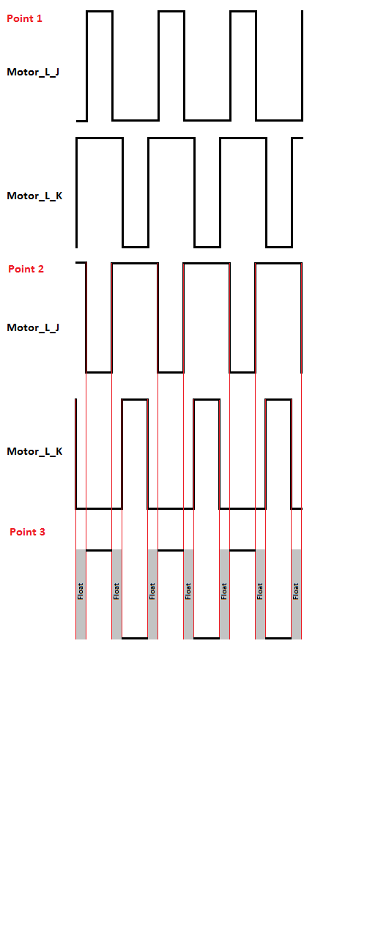

The first trace shows the previously derived waves for input Motor_L_J and Motor_L_K. These signals go to the gates of FETSs 9, 10, 11, 12.

Point 2 shows the signals on the drain pins of FETs 9 and 10, and on the gate pin of FETs 1 and 2. Due to the pull up resistor, when FET 9 or 10 are low, the signal is high, and when the FETs are allowing current flow, the signal goes low, creating this inverted wave.

Point 3 shows how these signals effect this side of the motor input. Due to FET1 being a p-channel FET, when is gate signal is low, it conducts. This produces the wave form at pin 2 of the motor. The delay has created a period when the pin is not connected to Vcc or ground.

This is for safety as if they were ever both connected, a short would be created.

If P74 is on, these same signals will be produced but with FETs 11 and 12 instead, while the outputs of FET 9 and 10 would hold pin 2 of the motor at ground. This effectively applies the same signal but with the pins switched around, reversing the motor.

## Speed Control and Feedback

In order for the car to handle optimally, forms of speed control need to be implemented, so that the car can brake and accelerate dynamically. With one or two feedback methods, a closed loop PID system can be created.

After some brief research, three methods of speed feedback were found, each with their own disadvantages and advantages.

**Optocoupler**- An optocoupler is made from an IR LED and an IR sensor, which will generate a pulse every time light is able to travel between them. This would be implemented by cutting holes in one of the gears and placing the optocoupler across them. The advantage of this is its low cost but would be larger than the alternatives. It would also have to be placed inconveniently above the gearbox, making it hard to get to for fault finding. The decision was made not to implement this method however it would be kept as a backup plan.

**Hall Effect Sensor**- A hall effect sensor is a small IC that will turn on or off depending on the magnetic flux present. This would require magnets to be attached to the real wheels so that the sensor would produce a square wave, with a frequency matching the wheels rotational speed in revolutions per second. The advantage of this is that the sensor would be placed right next to the wheel, making it much easier to access that the optocoupler. The main disadvantage is the need to attach magnets to the rear wheels, slightly increasing the load. This method was decided to be our main form of speed sensing.

**Accelerometer**- While normal used to measure acceleration, and accelerometer could be used with software integration to indirectly measure the speed. The method has the advantage of not having to change the mechanical design in any way, but as it is not a direct speed measurement, it may not be very accurate. This was decided to be a secondary measurement for speed, as well as helping dynamic braking and acceleration by giving acceleration feedback.

### Hall Effect Sensor

A hall effect sensor is and IC that can detect the presence of a magnetic field. They’re often used in motor control to measure rotating magnetic fields. The image below shows and example.

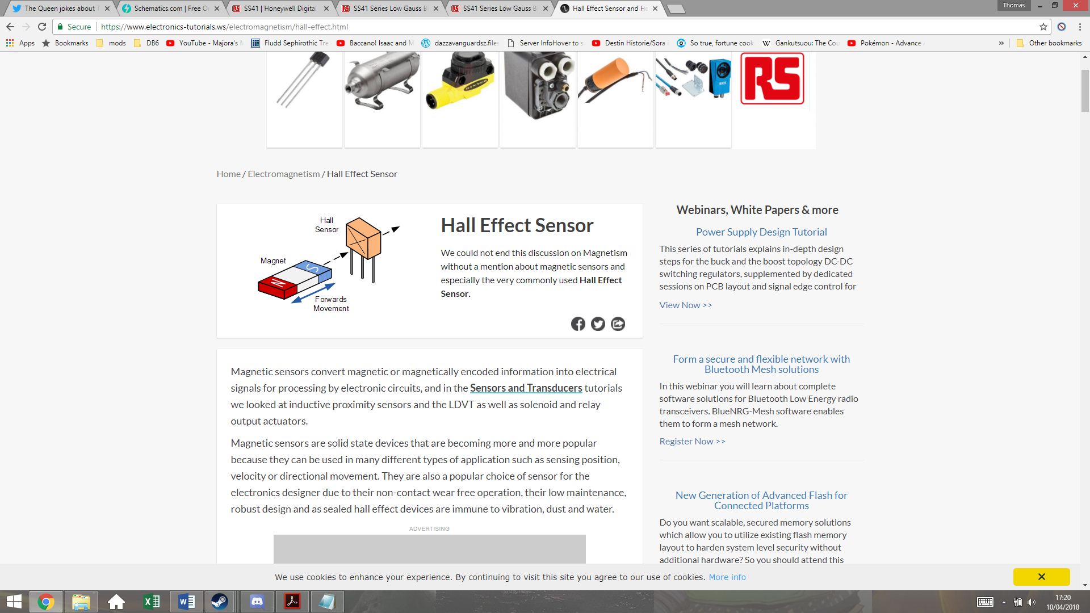

As a southern pole passes in front of the sensor, the output voltage goes high, and as a northern pole passes in front of the sensor, the output will return low. If the magnetic field is removed, it will maintain the same voltage. Meaning that it requires both poles to create an alternating signal.

Figure 1- Credit www.electronics-tutorials.ws

Both of the rear wheels will have two magnets attached on opposite sides to create a rotating magnetic field. These magnets will be attached with superglue, which should be enough to hold them even when the car is traveling at full speed. The magnets have to be placed exactly opposite each other, or this will create an unbalanced load on the DC motor. The magnets that will be used are Eclipse 5mm Neodymium Magnetic Discs, which are small but powerful. The diagram below shows how they will be positioned.

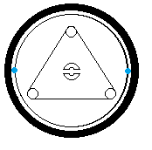The magnets will be placed on the rim of the wheels, next to but not touching the tire. The roll bar connector in the centre of the wheel can be used to make sure they are aligned with each other. These two magnets must be polar opposite so that they switch the sensor on and off with each rotation.

The Hall Effect sensor chosen is the SS41 Honeywell Digital Hall Effect Sensor. It has an input voltage range of 4.5-24V, meaning that it’s suitable to be run of the Vcc of the MCU board. Its maximum current draw when switching with a voltage supply of 5V is 8.7mA, which shouldn’t impact battery life significantly.

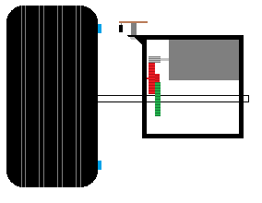

Hall effect sensor

Magnet

This image shows how the sensor must be positioned. The sensor is soldered onto a small piece of Veroboard, which is attached to the gear box using a screw and a spacer. The spacer is to keep it at the same level as the magnet. There is an air gap between the sensor and the magnet, but this should not be large enough to present a problem, given the strength of the magnets used.

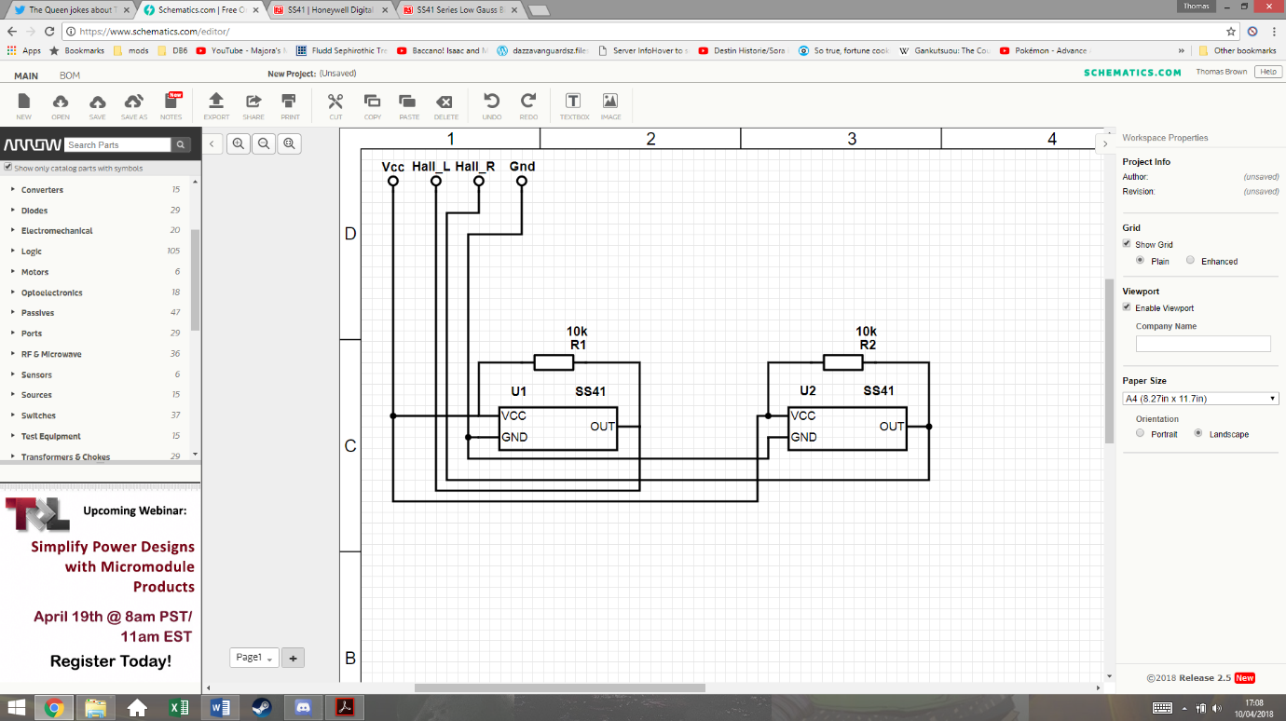This schematic shows how the system will be connected. The two Hall Effect sensors have pull-up resistors that prevent any floating values. They both share the Vcc and ground from the MCU board. The two outputs are then connected to I/O pins on the MCU board.

### Accelerometer

The use of an accelerometer in the car control allows the program to know the forces acting on the car. This can help prevent the car coming out of the track due to inertia and can also help breaking for the corners. For this application, only a two-axis accelerometer is required, as there should be no forces acting on the car perpendicular to the ground.

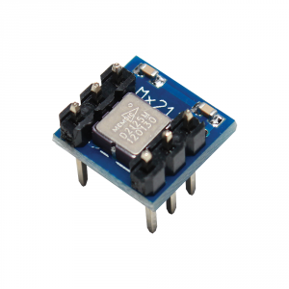The accelerometer chosen is the MESMIC 2125 two axis accelerometer. This can easily be inserted and removed from a standard 6 pin IC socket.

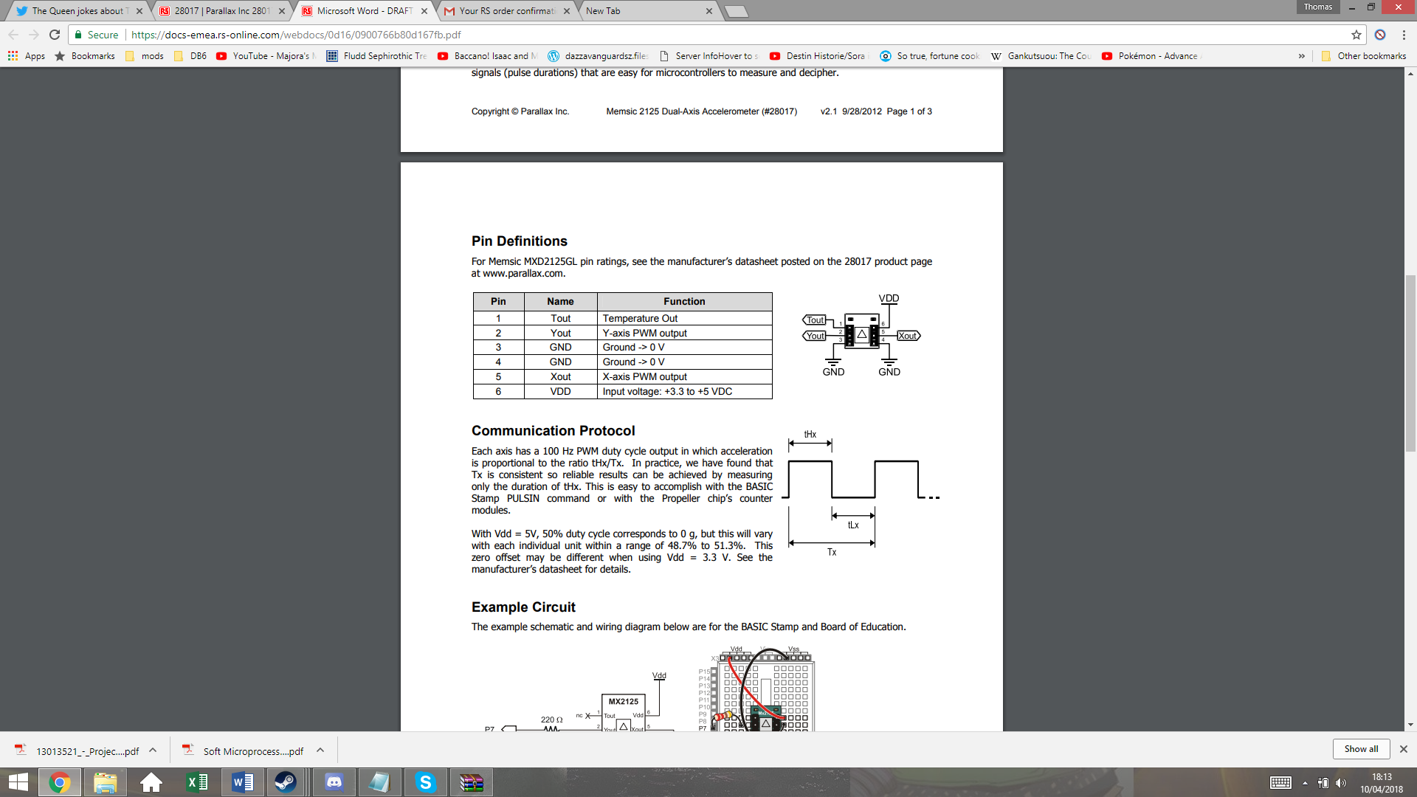

The supply voltage range for this device is 3.3-5Vdc, so this can also be run from the MCU boards Vcc. The output Xout and Yout will be used to give the X and Y coordinates of the vector of acceleration. These output give PWM signals, with duty cycles that vary in proportion to acceleration.

Tout is the temperature output from a thermistor inside the IC, but this will not be used in this system.

The datasheet states a sensitivity of 12.5% duty cycle per g on both axis, with 50% duty cycle representing 0 gg. This gives a range of +/-3 g. Taking g to be 9.81m/s^2, this gives a maximum measurable acceleration of 29.43m/s^2, which the car should not be able to exceed.

## Overall Electronic Design

Below is the overall electronic design, which shows all external connections to the MCU board.

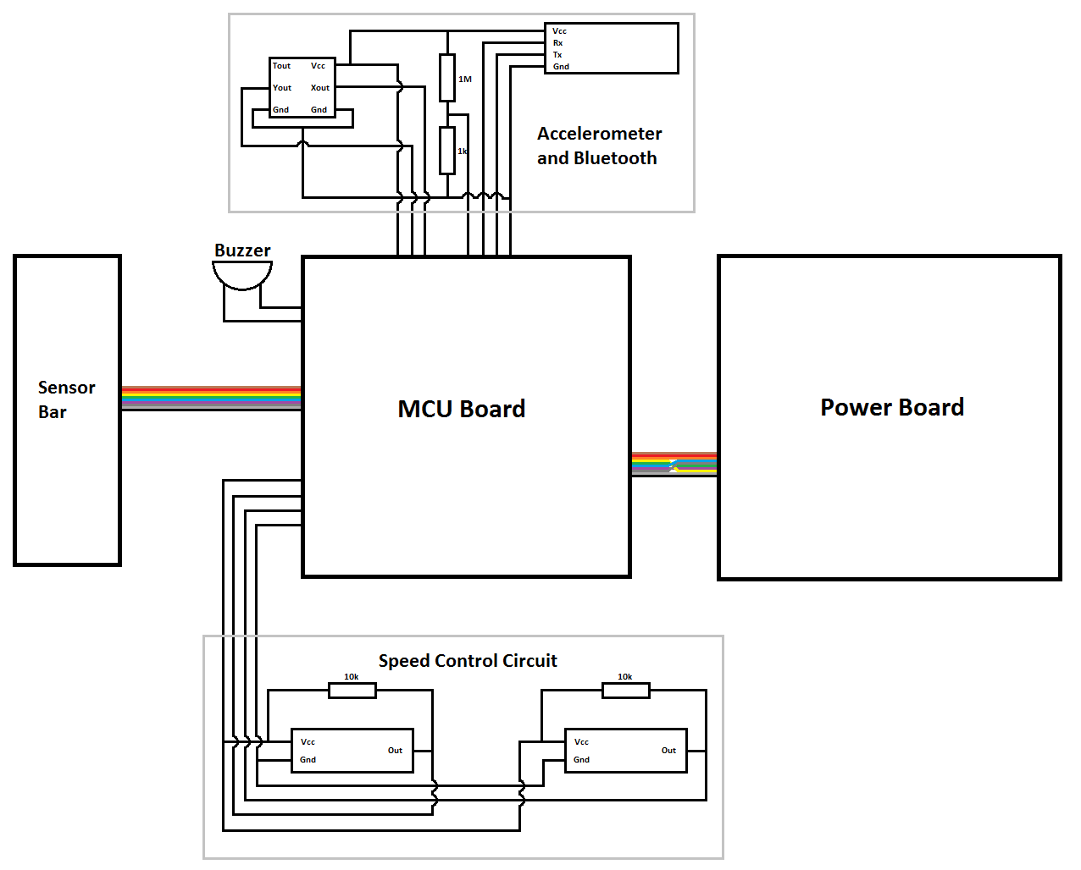

The speed control circuit requires 4 connections, for Vcc, left motor speed, right motor speed, and ground. The buzzer is attached between an MCU GPIO pin and ground, and is separate to the other systems so that it can be physically positioned anywhere. The peripheral board at the top has 7 connections. Vcc and ground for power, Xout and Yout from the accelerometer, Rx and Tx from the Bluetooth, and the scaled down battery voltage reading.

The power and sensor boards are connected via ribbon cord as per the original design.

## Control theory

## Software

### Program structure

### Backend

### Frontend

# Implementation

## Mechanical

The mechanical build started by using the provided plastic board to cut out and shape the bottom level board (point 1). This was cut out using a hacksaw and then a file and sandpaper were used to shape it and smooth down any rough edges.

This process was then repeated for the servo bridge and servo reinforcing plates (point 2). The servo reinforcing plates where attached to the bridge with screws and nuts so that they could be filed down together, however they would have to be removed later to attach the servo. The bridge was then attached to the bottom level board with the four pillars.

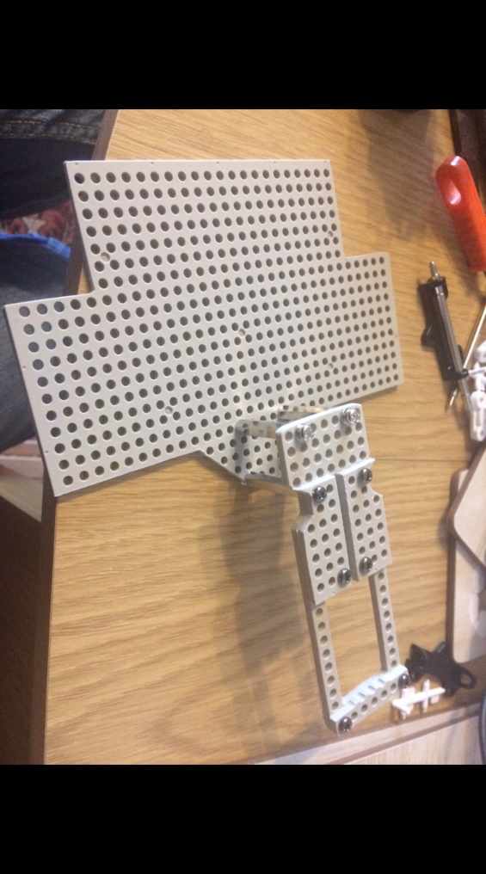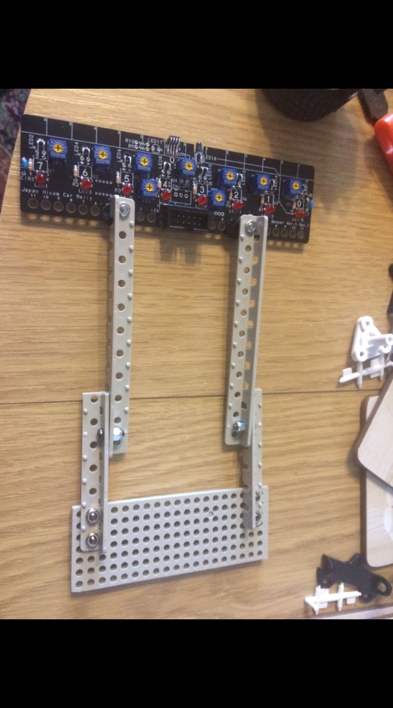

1

2

3

4

The axel is then cut out and shaped (point 3) but this is relatively easy as it’s just a rectangle. The arms are then assembled. The top part of the arms are already the correct length and shape, but the lower arms must be cut and smoothed.

The nylocs can be seen (point 4) one hole in to the lower part of the arm. This extra hole could be used to extend the length of the arms later on. The theory was that while longer arms may put more load on the servo, it would allow the car to detect changes in the line earlier.

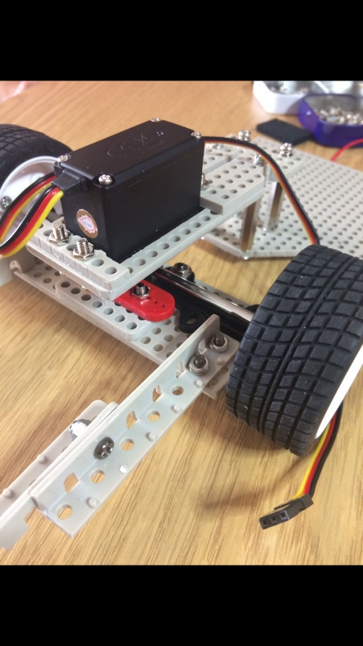

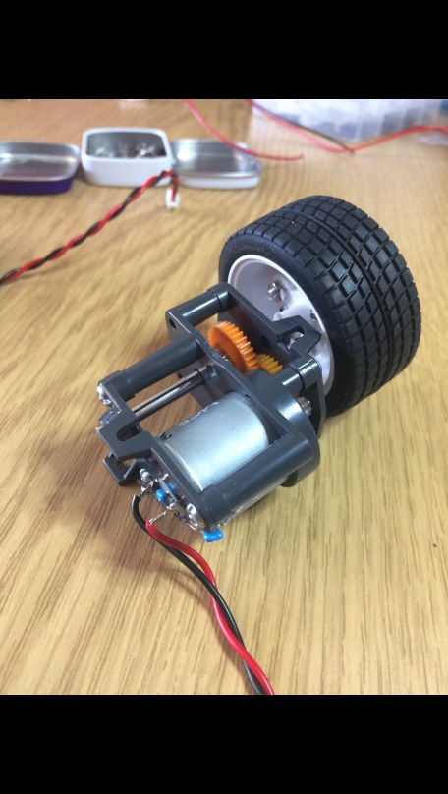

The gearboxes are then assembled ready to be mounted on the back. The motor is inserted into the housing before the capacitors and wires are soldered on, so that the contacts can slot through the back of the housing. The purpose of these capacitors are to filter noise and high frequency voltages from the PWM signals.

Once the wheel has been attached to the shaft and inserted into the housing, any extra shaft is cut away so that the gearboxes can be placed closely together. The shaft is held in place by a hexagonal gear joint and set screw. The gears are then positioned to complete the gearbox.

## Electrical

### Provided Circuits

The servo board was a simple build, however did require some accuracy in aligning the IR LEDs so that they all gave out an equal amount of light. After the build the potentiometers was adjusted to each give an equal voltage to the sensors, however this would be adjusted later to give the best sensitivity.

The power board was a much larger build, and to reduce the amount of time that may have been spent on fault finding, a great deal of care was put into the soldering of each component. The logic gate chips were soldered on a lower heat so as to be sure that they wouldn’t break.

The extra regulator components were added after testing the power board with a 5V supply.

### Hall Effect circuits

The image below shows one of the Hall Effect sensor board.

This was created by using a hacksaw to cut two small rectangles out of a piece of Veroboard, and then drilling the appropriate holes. The components were then soldered according to the schematic, making sure that there is no electrical path to the screws.

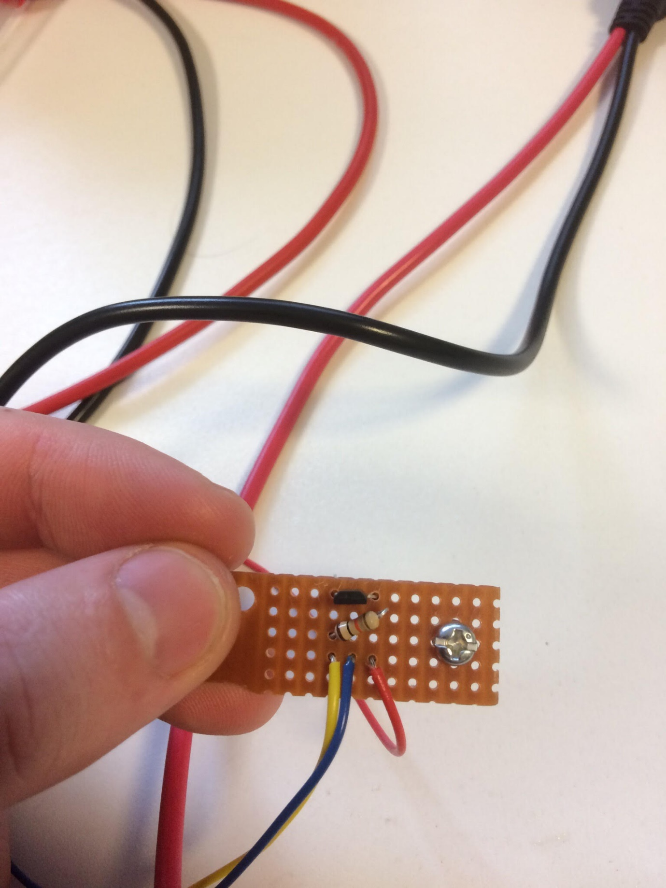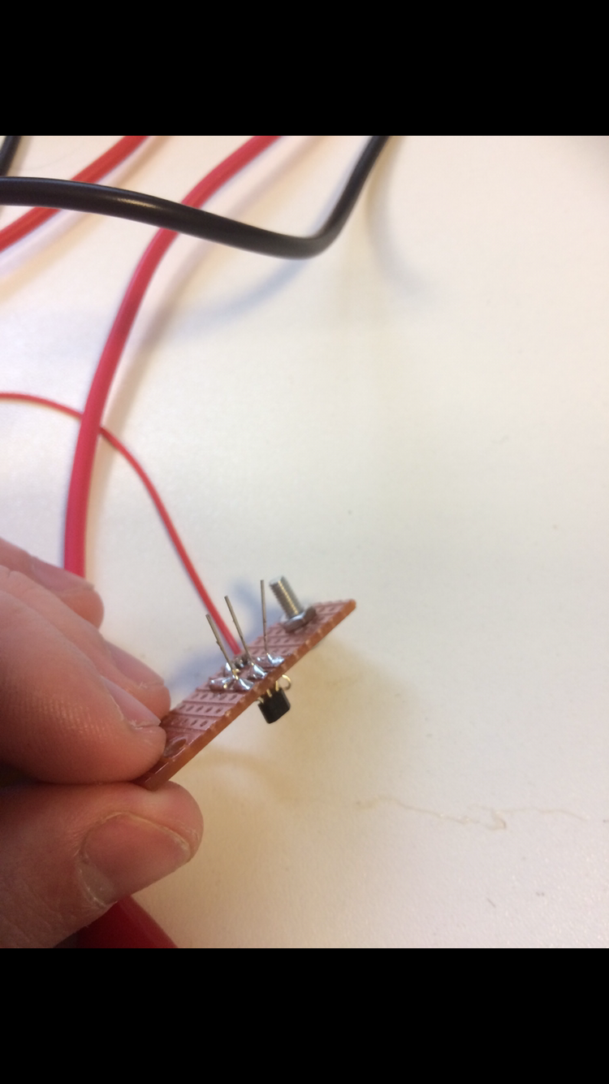

The legs of the Hall Effect sensors are not cut off just yet, as it makes testing easier if the legs are big enough to have crocodile clips attached.

### Peripheral Board

The peripheral board was an easy build. IC sockets were cut to the right sizes so that the accelerometer and Bluetooth systems could be removed is needed and didn’t have to be soldered directly. This is important because the accelerometer relies of temperature to function and exposing it to high temperatures could make it in accurate. Any extra copper on the Veroboard has been scratched away so as to reduce the risk of there ever being a short circuit.

Holes were drilled in the Veroboard so that it could be mounted behind the servo, as per the mechanical design, with spacers so that the bottom of the board does not touch the structure. The wires from the board are trimmed so that they are only as long as they need be, as they could otherwise get caught on something.

## Software

### Backend

#### RTOS

#### Peripheral drivers

#### Communication protocol

### Frontend

#### User application – car controller

##### Algorithm

##### Levels of intelligence

###### Basic

###### Advanced

###### Smart

#### User interactivity – command shell and Android App

### Extra features

#### MIDI Player

#### Wireless firmware deployment (bootloader)

#### Backward and forward compatibility

# Testing

## Mechanical

## Electrical

### Sensor board

<NOTE: KAYIN, WRITE YOUR CONTENT HERE>

## Software

# Performance

# Problems and solutions

<NOTE: KAYIN, WRITE YOUR CONTENT HERE>

# Next year proposals

# Discussions

# Conclusion

# References

Appendices

Appendix A:

Appendix B:

Appendix C: